Control Engineering II

Handout – Online Laboratory 6

Name: *Colda Andreea Ariana*

Group: *30332*

**Task 1:** What causes the nonlinear nature of the process?

Add answer here

It is a real life process and even if we change the voltage and then modify it to its previous value the degree will not be the same and the oscillations vary.

**Task 2:** Plot the experimental data (using plot(t,y)), as well as the step response of H(s) on the same figure to evaluate how well your model approximates the dynamics in the experimental data.

Add plot here

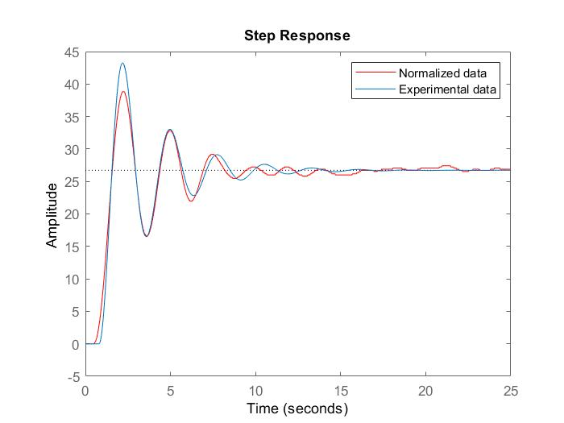

**Task 3:** Design an IMC controller for the VTOL process

Compute the equivalent controller

Add controller

0.065492 (s+2.5) (s+1.538)^3 (s^2 + 0.6934s + 5.244)

R(s) = --------------------------------------------------------------

s (s+1.538)^3 (s^2 + 4.615s + 8.557)

Simulate the response of the closed loop system to a step reference of 20o.

Add plot

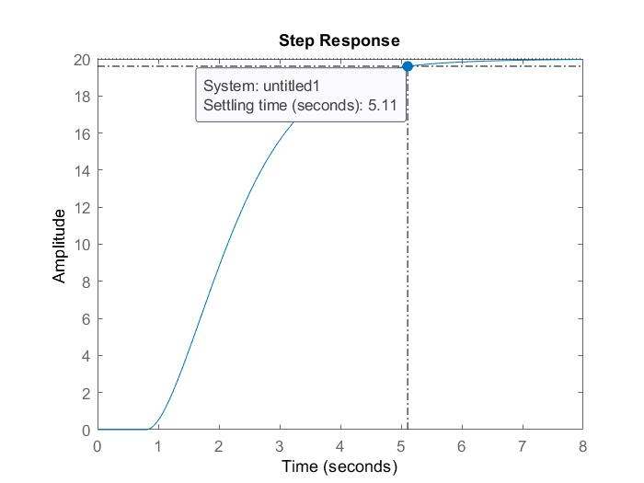

Compare the closed loop responses obtained with the continuous-time and discrete-time controllers. Plot the control signal for both cases and saturate it (remember that the control value can be between [0, 10] V).

Add plot

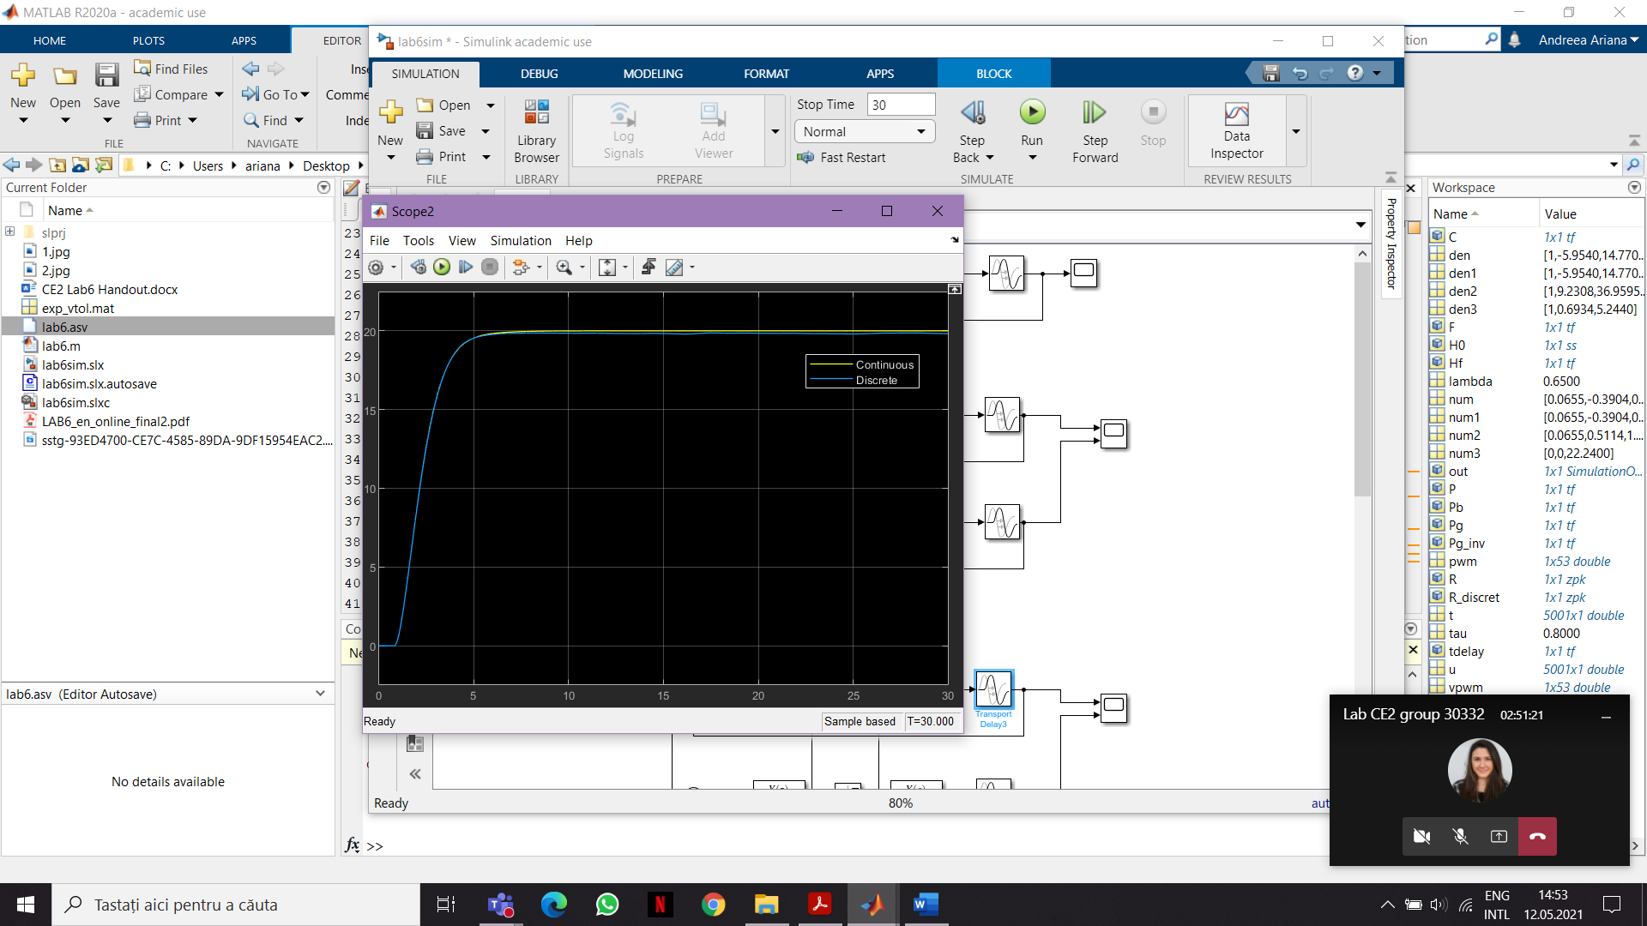

Control signal:

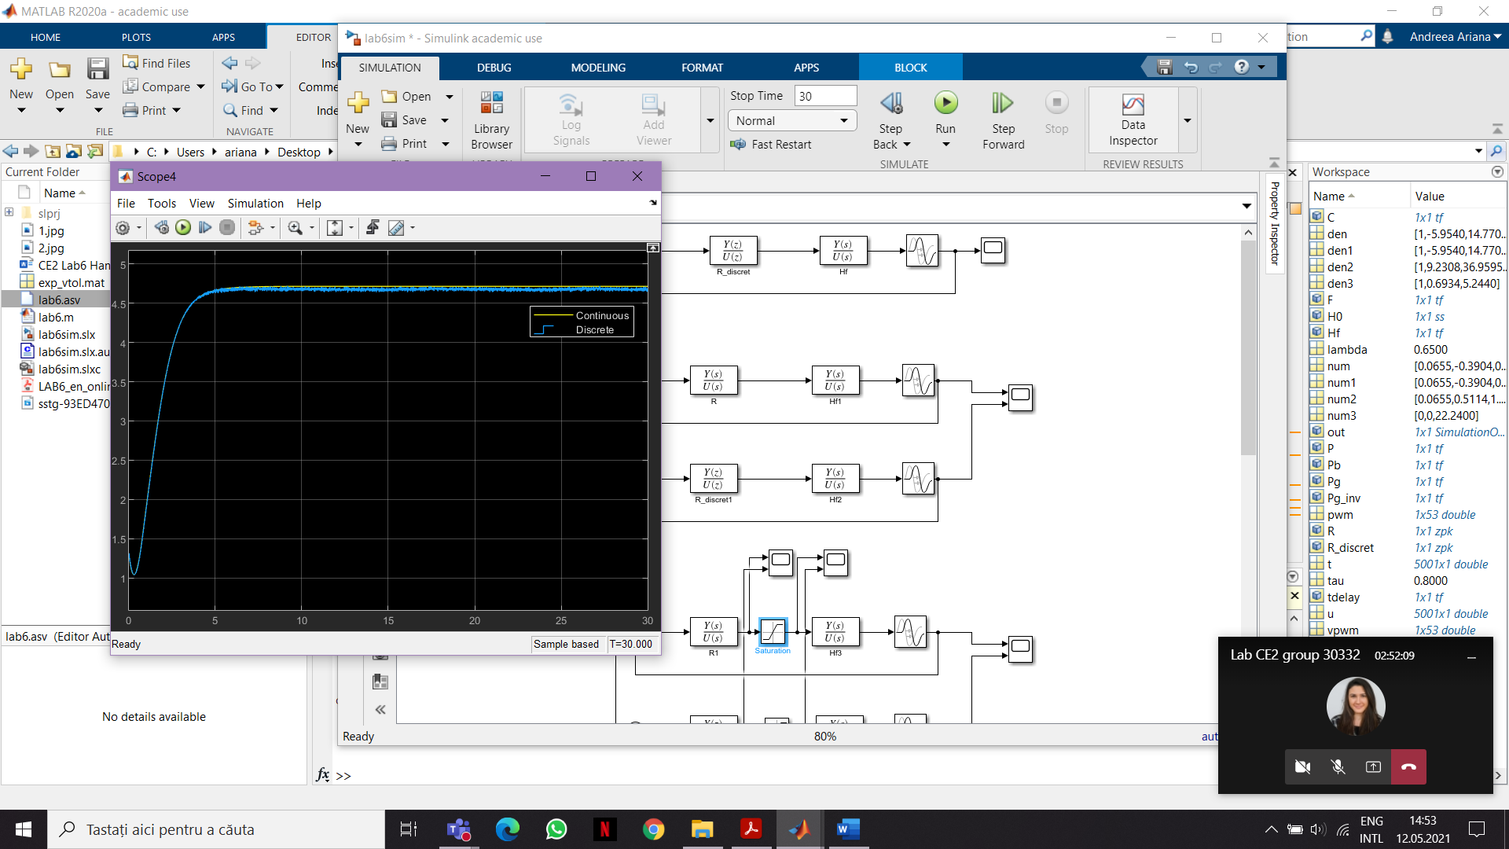

Introduce an output step disturbance of 50 at time t = 10s. How is the disturbance handled by the closed loop system?

Add plot and comments

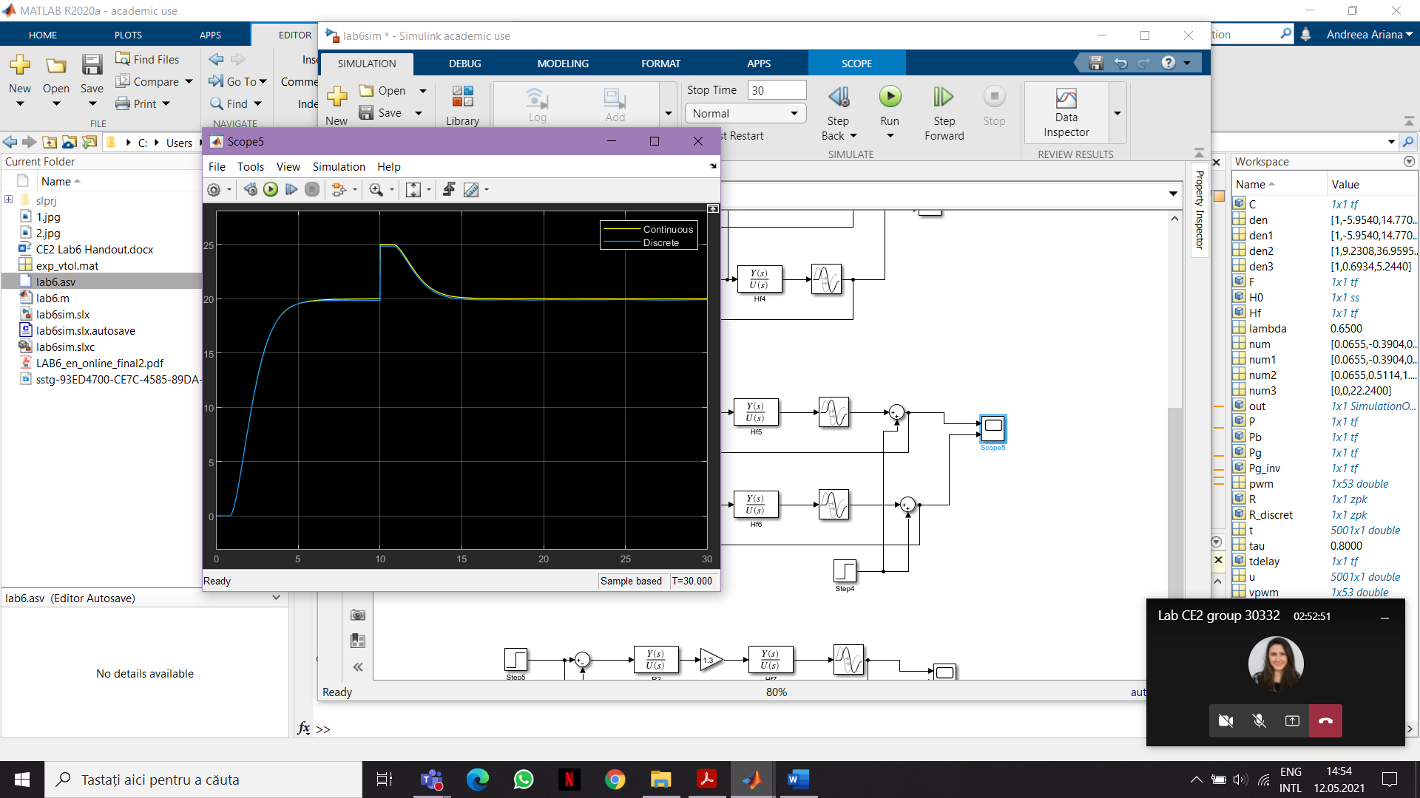

The disturbances are rejected.

Slightly alter the proportional gain of the transfer function of the process (change the value of kp by 5%-20%). Analyze the robustness of the closed loop system. What is the settling time in this case?

Add plot and comments

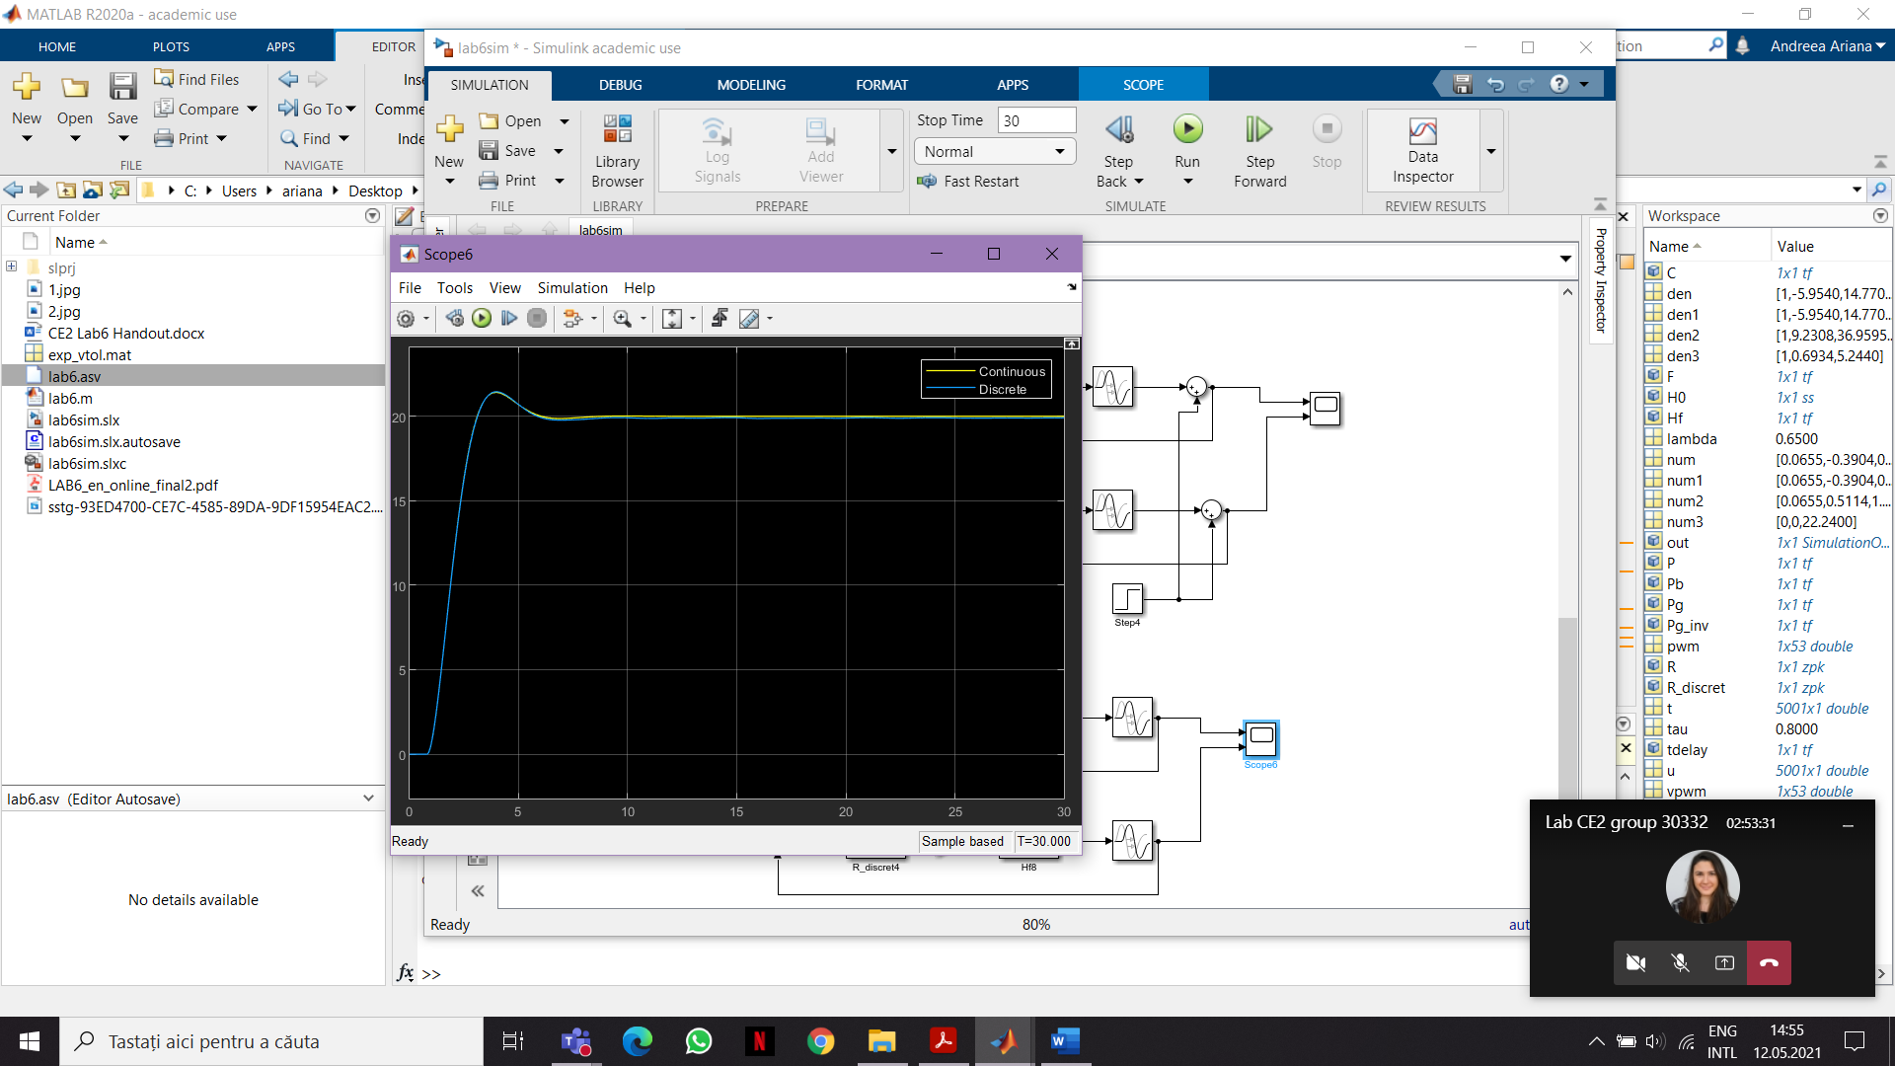

We can see that even if we introduce a gain of 1.3, the system settles, but the settling time changes. The settling time is about 10 sec.

Why is robustness important for Vertical Take-Off and Landing Platforms?

Add discussion